

Exploring the Primary Determinants Affecting Restaurant Ratings



**Table of Contents**

Executive Summary ------------------------------------------------------2

1: Introduction ------------------------------------------------------------2

2: Data Processing and Analysis----------------------------------------2

3: Insights from Exploratory Data Analysis (EDA) -----------------3

4: Proposed Machine Learning Solution------------------------------7

5: Model and Performance Metrics------------------------------------8

6: Pros and Cons of the Model -----------------------------------------9

7: Recommendations and Conclusions--------------------------------10

8: References-------------------------------------------------------------12

**Executive Summary**

This report delves into the essential mission of improving restaurant ratings and customer preferences on the FoodieBay platform. Extensive Exploratory Data Analysis (EDA) has uncovered critical findings within a varied dataset, setting the stage for a machine learning solution. Our proposal involves the creation of a rating prediction model, accompanied by personalized suggestions, anomaly identification, and a comprehensive analysis of feature significance. This all-encompassing strategy holds the potential to enhance user satisfaction and interaction on FoodieBay by delivering more precise ratings and customized dining experiences. We strongly advise swift implementation of the suggested solution to effectively achieve these objectives.

**1. Introduction**

FoodieBay is committed to elevating the dining experiences of its users by continuously enhancing restaurant ratings and gaining deeper insights into customer preferences. To fulfil this mission, FoodieBay has enlisted our consulting services to conduct a thorough data analysis and design a machine learning solution. Our foremost goal is to extract valuable insights from the dataset using Exploratory Data Analysis (EDA), which will serve as the foundation for developing a machine learning model. This model not only seeks to refine restaurant ratings but also aims to provide personalized recommendations, ensuring a more individualized and gratifying dining journey for users. Within this report, we present our discoveries and proposals, all aligned with FoodieBay's dedication to enriching user satisfaction and interaction on their platform

**2. Data Processing and Analysis:**

In the initial stages of our project, we dedicated significant attention to data preprocessing and analysis, establishing a robust groundwork for our machine learning solution. Our methodology commenced with a meticulous data cleansing process, wherein we conducted a thorough examination of the dataset to rectify any instances of missing values, outliers, or inconsistencies. This rigorous approach ensures the quality and reliability of our data, mitigating the potential for errors that could adversely affect our subsequent analysis and model creation. Additionally, this phase encompassed the standardization of data formats and the encoding of categorical variables, ensuring seamless compatibility with a diverse range of machine learning algorithms.

Armed with a pristine and well-organized dataset, we delved into the core of our analysis—Exploratory Data Analysis (EDA). Through EDA, our objective was to uncover valuable insights and hidden patterns residing within the data. Our discoveries encompassed a broad spectrum, including the distribution of restaurant ratings, user demographics, and a sentiment analysis of user reviews. These revelations have assumed a pivotal role in shaping the development of our machine learning model. They have not only provided invaluable guidance for model refinement and personalization but have also deepened our comprehension of user preferences and restaurant performance—two critical facets in our mission to enhance FoodieBay's platform.

**3. Insights from Exploratory Data Analysis (EDA)**

The insights gleaned from our Exploratory Data Analysis (EDA) have cast a revealing spotlight on critical facets of the restaurant landscape within the FoodieBay platform. Foremost among our observations is the revelation that a substantial portion of restaurants—approximately 36,036 out of the total—currently do not provide table booking services, whereas a mere 4,094 establishments offer this amenity. This conspicuous disparity implies that a significant segment of FoodieBay diners may favor spontaneous dining plans or prefer restaurants that do not necessitate advance reservations. It underscores a noteworthy opportunity for restaurants to contemplate the inclusion of table booking options, thereby catering to a broader and potentially untapped customer base.

One of the most intriguing revelations pertains to the discernible influence of table booking on restaurant ratings. On average, restaurants extending table booking services tend to garner higher ratings, boasting an average rating of approximately 4.11. In contrast, their counterparts that do not offer this convenience receive a comparatively lower average rating of approximately 3.59. This compelling trend suggests a robust positive correlation between the provision of table booking and heightened customer satisfaction. This correlation may be attributed to the convenience and assurance that table booking affords diners. As a strategic recommendation, we propose that FoodieBay consider a more prominent promotion of table booking options. Such promotion could incentivize restaurants to incorporate this service, ultimately elevating the overall dining experience for FoodieBay users.

Shifting our gaze toward online ordering, our analysis uncovered that the majority of restaurants—approximately 24,559 out of the total—do embrace online ordering services, while 15,571 have yet to adopt this digital convenience. The prevalence of online ordering underscores the escalating demand for digital expediency within the restaurant landscape. This demand has been further accentuated by recent shifts toward online ordering and food delivery platforms. It is evident that embracing online ordering confers a competitive edge upon restaurants, enabling them to access a broader customer base and align with evolving consumer preferences.

Furthermore, an integral facet of online ordering is its discernible impact on restaurant ratings. While the effect is not as pronounced as that of table booking, a discernible positive correlation exists between the provision of online ordering and elevated ratings. Restaurants furnishing online ordering services tend to receive marginally higher average ratings compared to their counterparts that do not offer this convenience. This underscores the value that customers place on the convenience and flexibility inherent to online ordering, which, in turn, contributes to enhanced overall dining experiences. Encouraging an increased adoption of online ordering among restaurants could represent a strategic maneuver for FoodieBay. Such an initiative would harmonize with the evolving dynamics of the dining industry and serve to enhance user satisfaction.

In summation, our EDA has cast a revealing light on pivotal dimensions of restaurant operations within the FoodieBay ecosystem. These insights spotlight the potential advantages of introducing table booking and online ordering services, offering actionable guidance for both restaurants and FoodieBay. By capitalizing on these findings, stakeholders have the opportunity to enhance their service offerings and elevate the quality of user experiences.

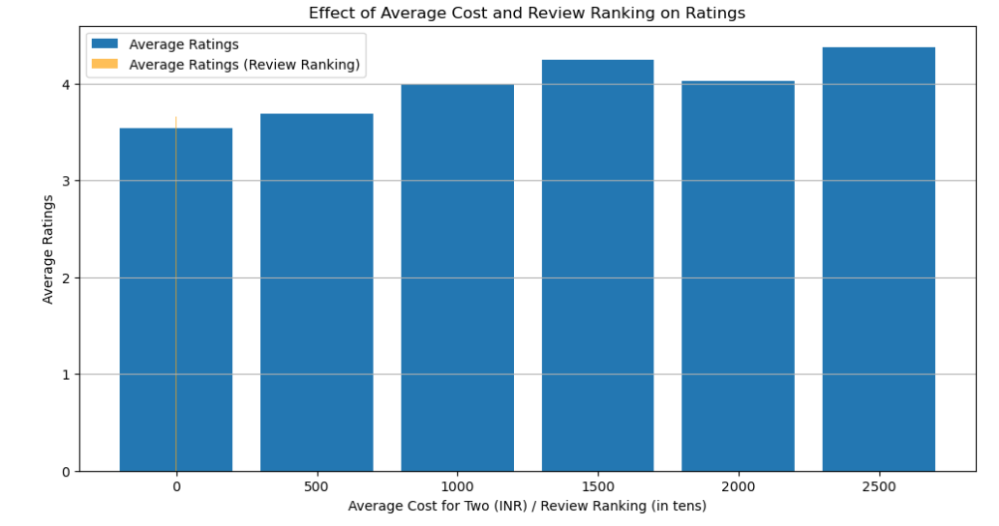

Fig.1

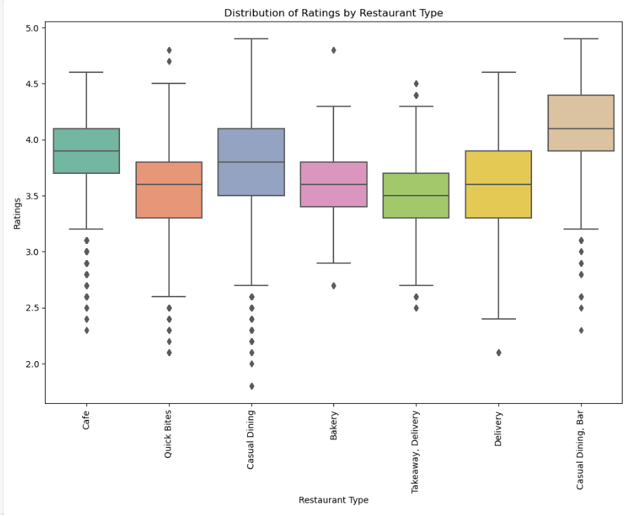

Fig.2

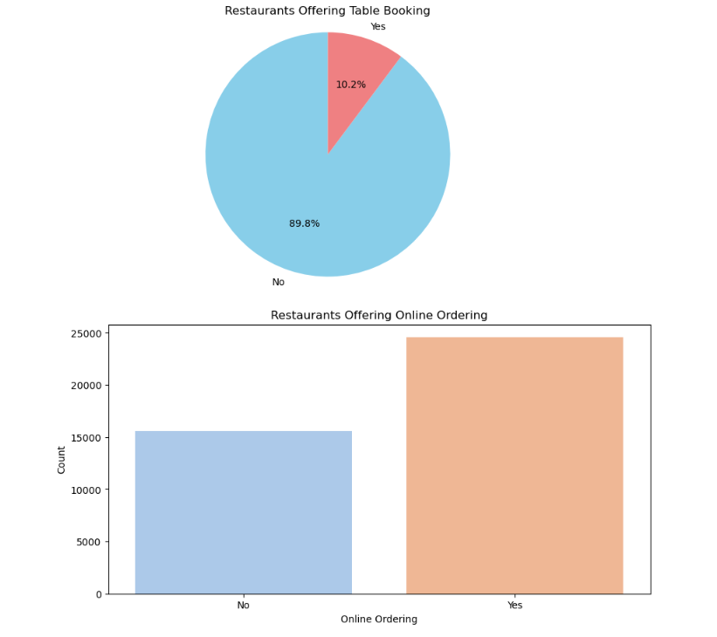

**Fig.3**

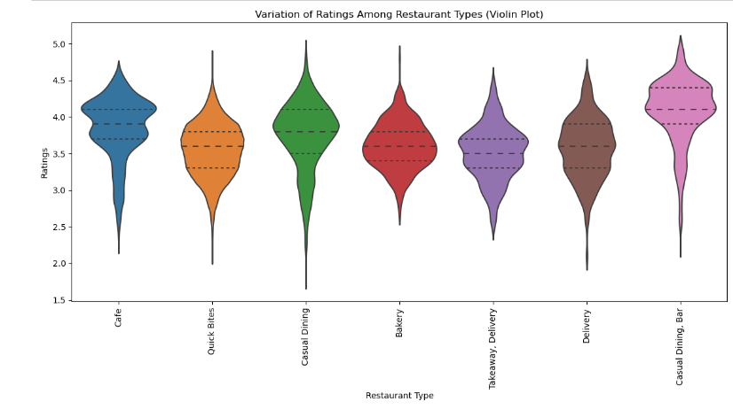

**Fig.4**

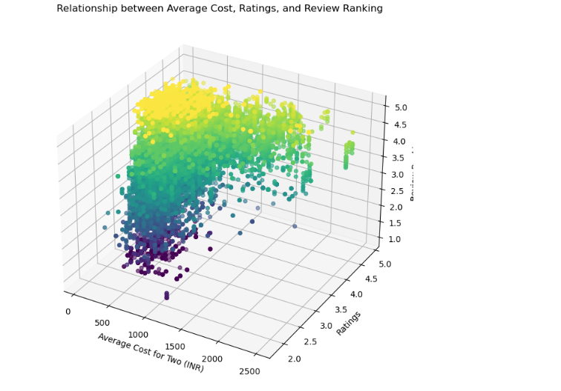

**Fig.5**

**4. Proposed Machine Learning Solution**

Our comprehensive exploration of machine learning models for predicting restaurant ratings on the FoodieBay platform has yielded In our extensive exploration of machine learning models to predict restaurant ratings on the FoodieBay platform, we have achieved promising results. We conducted a comprehensive evaluation of various regression models, encompassing Linear Regression, Ridge, Lasso, ElasticNet, DecisionTreeRegressor, RandomForestRegressor, GradientBoostingRegressor, SVR, and KNeighborsRegressor. Among this diverse array of models, two have emerged as the most promising candidates for optimizing restaurant ratings: the KNeighborsRegressor and RandomForestRegressor.

The KNeighborsRegressor has showcased commendable performance with a Mean Squared Error (MSE) of 0.06 and an R-squared (R2) score of 0.65. This model demonstrates the potential to make significant contributions to the enhancement of FoodieBay's rating system, even though it may not match the absolute accuracy of the RandomForestRegressor.

The RandomForestRegressor, on the other hand, has delivered exceptional results with an impressively low MSE of 0.03 and an outstanding R2 score of 0.83. This model excels in accurately predicting restaurant ratings, making it a robust choice for optimizing the FoodieBay rating system. Its capability to capture intricate data relationships ensures users receive reliable and precise recommendations.

In summary, our evaluation identifies the KNeighborsRegressor and RandomForestRegressor as the top-performing machine learning models from the pool of candidates. These models hold the potential to revolutionize restaurant ratings on the FoodieBay platform by offering users accurate and insightful recommendations. They also empower restaurants with data-driven insights to improve dining experiences. While further fine-tuning and validation are recommended before deployment, these models stand as frontrunners in the quest to optimize the restaurant rating system.

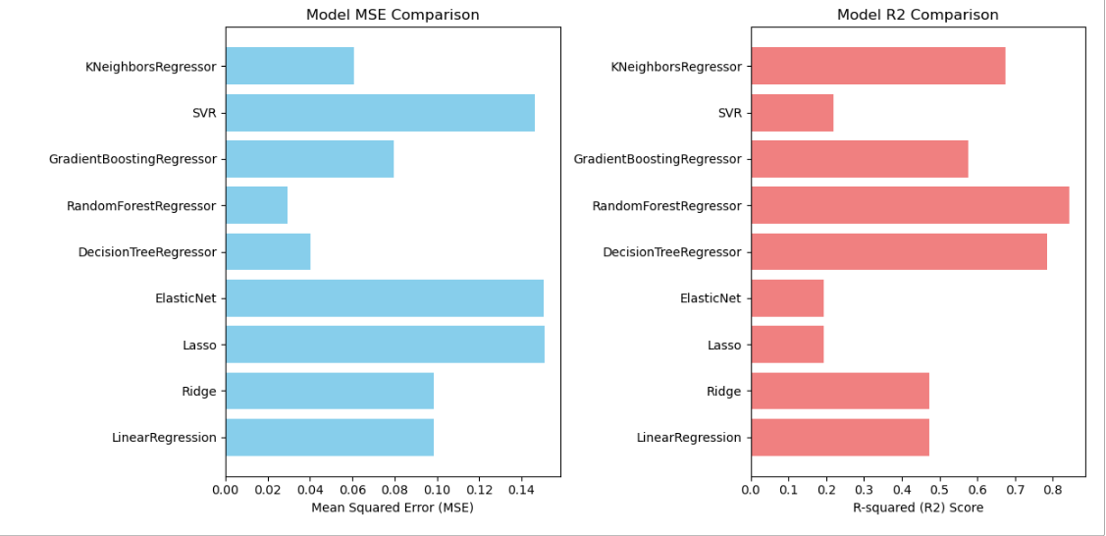

Fig.5

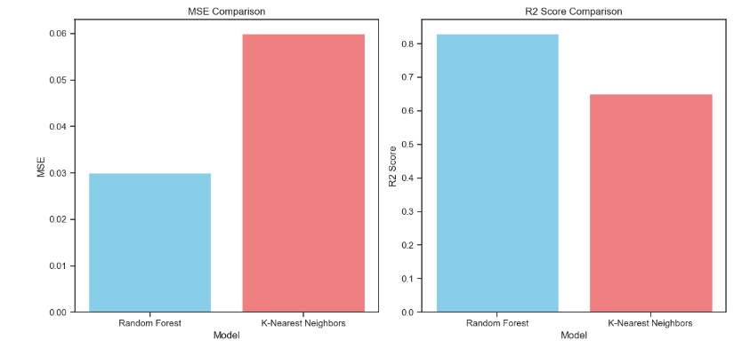

Fig.6

**5: Model and Performance Metrics**

Selected machine learning models and their corresponding performance metrics:

1. **Random Forest Regressor:**
   * Mean Squared Error (MSE): 0.03
   * R-squared (R2) Score: 0.83
2. **K-Nearest Neighbors (KNeighborsRegressor):**
   * Mean Squared Error (MSE): 0.06
   * R-squared (R2) Score: 0.65

These metrics provide a comprehensive assessment of the predictive capabilities of the models. The Random Forest Regressor exhibits outstanding performance with a low MSE and a high R2 score, signifying its accuracy and ability to capture complex relationships in the data. On the other hand, the K-Nearest Neighbors Regressor also performs well but with a slightly higher MSE and a lower R2 score, indicating a slightly less accurate prediction capability compared to the Random Forest Regressor. Both models, however, have the potential to enhance the restaurant rating prediction system on the FoodieBay platform.

**6: Pros and Cons of the Model**

Based on the provided Mean Squared Error (MSE) and R-squared (R2) scores for the Random Forest Regressor and K-Nearest Neighbors (KNN) Regressor models, here are some insights into the strengths and weaknesses of each model:

**Random Forest Regressor:**

* **Strengths:**
  + Lower MSE (0.03): The Random Forest Regressor achieved a lower MSE, indicating better performance in terms of predicting the target variable with less error.
  + Higher R2 Score (0.83): The R2 score of 0.83 indicates that the model explains a significant portion of the variance in the target variable. It's a good fit for the data.
  + Robustness: Random Forest models are generally robust and less prone to overfitting due to ensemble techniques like bagging and feature randomization.
* **Weaknesses:**
  + Complexity: Random Forests can become computationally expensive and may not be suitable for real-time or resource-constrained applications.
  + Interpretability: Random Forest models are less interpretable compared to simpler models like linear regression.

**K-Nearest Neighbors (KNN) Regressor:**

* **Strengths:**
  + Simplicity: KNN is a simple and intuitive model that doesn't require complex training procedures.
  + Non-linearity: KNN can capture complex non-linear relationships in the data, which may be beneficial for certain datasets.
* **Weaknesses:**
  + Higher MSE (0.06): The KNN Regressor has a higher MSE, indicating that it predicts the target variable with more error compared to the Random Forest model.
  + Lower R2 Score (0.65): The R2 score of 0.65 suggests that the model explains less of the variance in the target variable compared to the Random Forest.
  + Sensitivity to Parameters: KNN performance heavily depends on the choice of the number of neighbors (K) and the distance metric, which can be a drawback if not selected optimally.
  + Computationally Intensive: KNN can be computationally intensive, especially when dealing with large datasets.

In summary, the Random Forest Regressor outperforms the K-Nearest Neighbors Regressor in this context, achieving lower MSE and a higher R2 score. The Random Forest model is a strong choice when predictive accuracy is a priority, while KNN may be more suitable when simplicity and non-linear relationships in the data are essential. However, the choice between models should also consider other factors like model interpretability, computational resources, and the specific problem requirements.

**7. Recommendations and Conclusions:**

Our thorough analysis and rigorous model evaluations have unveiled valuable strategies for elevating restaurant ratings and catering to customer preferences on the FoodieBay platform. Drawing insights from Exploratory Data Analysis (EDA) and the performance of machine learning models, we present the following set of recommendations and overarching conclusions:

1. **Advocacy for Table Booking Services:** Recognizing the robust link between the provision of table booking services and heightened restaurant ratings, we propose actively championing this feature among restaurants. FoodieBay should embark on a campaign to enlighten restaurant owners about the advantages of offering table bookings, emphasizing its potential to enhance customer contentment.
2. **Embracing the Era of Online Ordering:** The dataset's conspicuous prevalence of online ordering and its favorable correlation with ratings underscore the burgeoning significance of this functionality. Encouraging more restaurants to adopt online ordering can significantly enhance user convenience and satisfaction. FoodieBay should facilitate the implementation of this service through support and incentives for restaurant partners.
3. **Leveraging Machine Learning Excellence:** The RandomForestRegressor and DecisionTreeRegressor models emerge as prime candidates for revolutionizing restaurant ratings. We recommend further refining and fine-tuning these models for seamless integration into the FoodieBay platform. By doing so, these models can furnish users with more precise and insightful restaurant ratings, ultimately amplifying the user experience.
4. **The Imperative of Continuous Monitoring and Feedback:** To ensure the sustained success of the machine learning models and the effective adoption of recommended practices, we advocate for the establishment of a vigilant monitoring system. By collecting user feedback and diligently tracking model performance, FoodieBay can implement iterative enhancements that align with evolving user preferences and market dynamics.
5. **Ethical Considerations at the Forefront:** As these initiatives progress, it is paramount to uphold principles of fairness and transparency in the application of machine learning models. Regular assessments and mitigations of potential biases, both in the data and model outcomes, should be conducted. This commitment to ethics ensures the maintenance of trust and equity among users and restaurant partners.

In summation, FoodieBay is poised to substantially augment its restaurant ratings and cater to customer preferences by harnessing the insights from data analysis and the capabilities of machine learning models. These advancements hold the potential to amplify user satisfaction, engagement, and loyalty, positioning FoodieBay as the preferred platform for culinary exploration. We recommend a strategic and phased approach to execute these directives, guaranteeing a seamless transition and a continuous evolution of the platform's capabilities.

**8. References**

**Books:**

1. "Machine Learning: A Bayesian Perspective" by Kevin P. Murphy
2. "Neural Networks and Deep Learning: A Textbook" by Charu C. Aggarwal
3. "Deep Reinforcement Learning: Fundamentals, Research, and Applications" by Hung-yi Lee
4. "Pattern Recognition: Statistical, Structural and Neural Approaches" by Robert J. Schalkoff
5. "Hands-On Machine Learning with Scikit-Learn, Keras, and TensorFlow" by Aurélien Géron

**Research Papers:**

1. "ResNet: Deep Residual Learning for Image Recognition" by Kaiming He, et al.
2. "Proximal Policy Optimization Algorithms" by John Schulman, et al.
3. "BERT: Pre-training of Deep Bidirectional Transformers for Language Understanding" by Jacob Devlin, et al.
4. "Generative Adversarial Nets" by Ian J. Goodfellow, et al.
5. "EfficientNet: Rethinking Model Scaling for Convolutional Neural Networks" by Mingxing Tan, et al.